Extra dataset : Chinook dataset

This extra dataset (names chinook) is documented here : <http://www.sqlitetutorial.net/sqlite-sample-database/>. It was originally a SQLite database (an open-source RDBMS), but is already translated to SAS tables. You can find the ERD scheme below (note that this is a different notation, typically used by Oracle databases as well, named Crow’s foot notation. The interpretation is fairly straightforward. You can find a description of the database below.

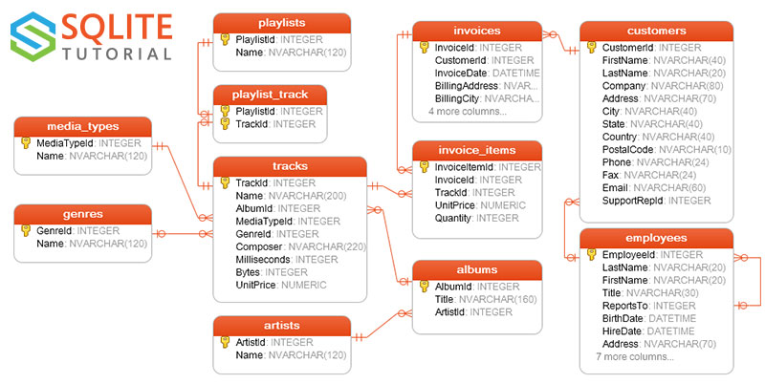

The notation is different from the typical ER-diagram notation of Chen. In this representation, entities are represented as relations, and the relations can be interpreted as follows:

* Between media types and tracks: A track can have one and only one media type (|| on the line) and a media type can be linked to zero, one or more tracks (circle with three stripes)
* Between genre and tracks: a genre can be linked to zero, one or more tracks, while each track is linked to zero or one genre (|0).

There are 11 tables in the chinook sample database.

* employees table stores employees data such as employee id, last name, first name, etc. It also has a field named ReportsTo to specify who reports to whom.
* customers table stores customers data.
* invoices & invoice_items tables: these two tables store invoice data. The invoices table stores invoice header data and the invoice_items table stores the invoice line items data.
* artists table stores artists data. It is a simple table that contains only artist id and name.
* albums table stores data about a list of tracks. Each album belongs to one artist. However, one artist may have multiple albums.
* media_types table stores media types such as MPEG audio file, ACC audio file, etc.
* genres table stores music types such as rock, jazz, metal, etc.
* tracks table store the data of songs. Each track belongs to one album.
* playlists & playlist_track tables: playlists table store data about playlists. Each playlist contains a list of tracks. Each track may belong to multiple playlists. The relationship between the playlists table and tracks table is many-to-many. The playlist_track table is used to reflect this relationship.